**Use case 9**

**Domain: Environment**

**Case- Automated Species Identification and Monitoring in the Jungle**

**Problem statement:**

In a dense jungle or rainforest, it can be challenging for researchers to effectively monitor and identify the diverse range of animal species inhabiting the area. Traditional methods often involve manual observation, which can be time-consuming and limited by the availability of human resources. AI can play a pivotal role in automating acoustic monitoring and species identification in such environments.

**Solution:**

AI-powered acoustic monitoring systems can be deployed in the jungle, utilizing an array of audio sensors or microphones strategically placed across the forest.

**Data Collection**

**Audio Data Collection**: Microphones are set up to continuously record sounds in the jungle. This audio data includes a wide range of sounds, including bird calls, animal vocalizations, and other environmental noises.

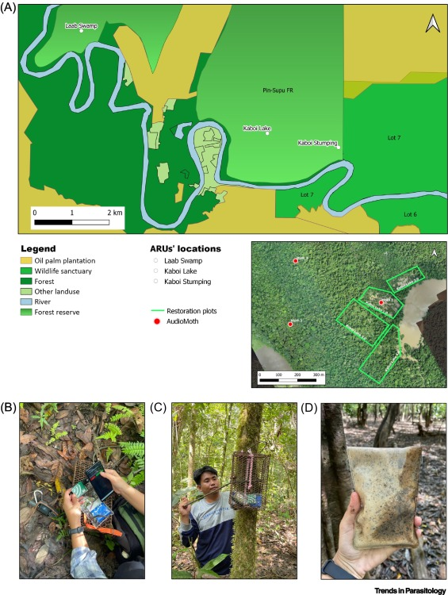

**Set-up and deployment of autonomous recording unit (ARU) in Sabah, Malaysia.**

**Data Preprocessing**: The collected audio data is preprocessed to filter out background noise, enhance audio quality, and segment recordings into manageable chunks.

**Feature Extraction**: AI algorithms extract relevant features from the audio data, such as frequency, duration, and amplitude of sounds. These features are used as input for the AI model.

**Machine Learning Models**: Machine learning models, such as deep learning-based neural networks, are trained on a labeled dataset of jungle sounds. Researchers contribute to this dataset by identifying species in audio recordings. The AI models learn to recognize the distinctive audio patterns associated with various animal species.

**Species Identification**: When deployed in the jungle, the AI system continuously analyzes incoming audio data in real-time. It can automatically detect and identify animal species based on the audio features. For example, it can distinguish between different bird species, primates, or other animals.

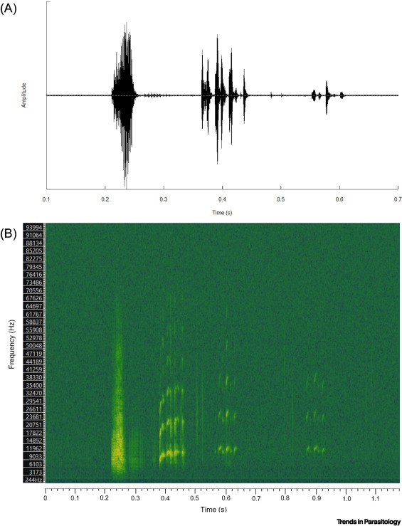 

Spectrogram (time–amplitude–frequency) for Egyptian fruit bat vocalisation

**Alerts and Reporting**: The AI system can generate real-time alerts when it detects rare or endangered species, unusual behavior, or potential threats such as illegal logging or poaching activities. These alerts can be sent to researchers or park rangers for immediate action.

**Benefits:**

* Efficient Monitoring
* Biodiversity Research
* Protection Against Illegal Activities
* Continuous Monitoring
* Data Analysis